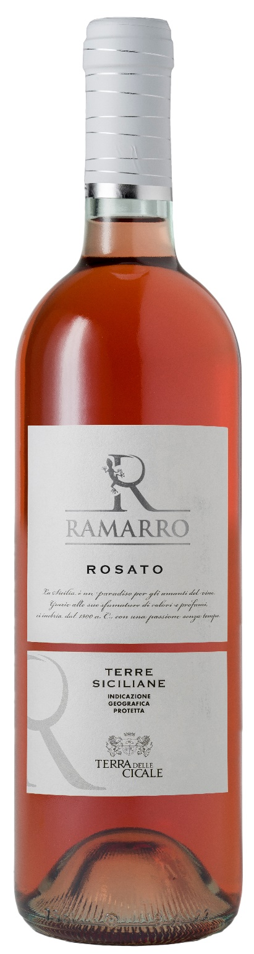
ROSATO TERRE SICILIANE IGP – RAMARRO

Grape: Pinot Nero, Nero d’Avola
Alc. Vol.%: 12
Vintage: 2025
Residual sugar g/l: 4,5
Total acidity g/l: 5,7
Region: Sicily
Production zone: Vineyards in the province of Mazara del Vallo (Trapani)
Capacity: 750ml

CHARACTERISTICS

Vinification: Short contact with the berry skins, then fermentation at a controlled temperature of 16°C
Aging: In steel tanks until bottling
Yield per ha: 14000kg
Colour: Light and bright rosé
Bouquet: Fresh and fruity
Flavour: Fresh with pleasant fruity notes

SERVING SUGGESTIONS

Best with starters and fish dishes.
Serving temperature 6-8 °C
TECHNICAL INFORMATION / PALLETIZING

Size 750ml:
Article Nr. V11009A
GTIN-13 bottle 8017868003335
GTIN-13 carton 8017868003113
Closure Cork/Screwcap
Bottles / carton 6 bottles
Pallet size 80x120cm
Cartons/layer 25
Cartons/pallet 125
Kg/carton 7,0
Kg/pallet 892

Contains sulphites
GMO Free
Revisione 01. 14.05.2026

